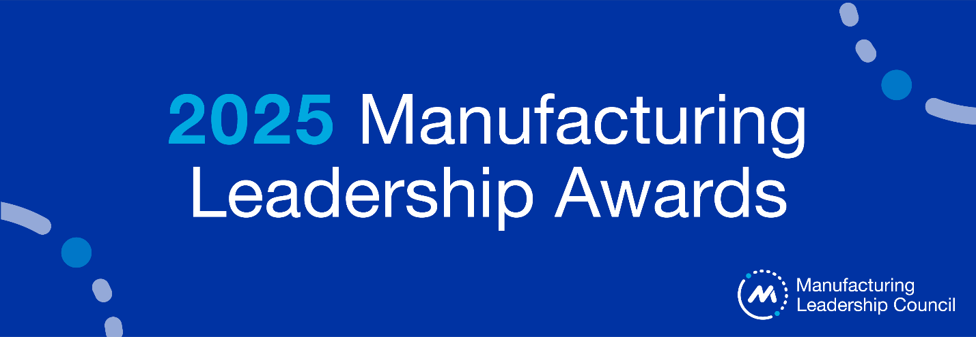
FINALIST PRESS RELEASE TEMPLATE - Project
***The following press release template is meant to be a guide to help your company share the news about your achievement. Note: Please do not issue any public announcements until April 18, 2025, or later. You are welcome to use any copy in this template, in particular phrasing that relates to the Awards program, the Manufacturing Leadership Council and National Association of Manufacturers. If you have any questions, please contact Penelope Brown at pbrown@nam.org. ***
FOR IMMEDIATE RELEASE
_[COMPANY]__ Recognized as 2025 Manufacturing Leadership Awards Finalist
[team or project name] is honored for enabling manufacturing excellence
City, ST — April xx, 2025 — [insert company and descriptor] today announced that it has been recognized as a finalist in the 2025 Manufacturing Leadership Awards for its outstanding achievement in [insert project award category].
The [project] enabled [company] to [describe project and/or achievements].
[Company] will be recognized along with all other award finalists at the Manufacturing Leadership Awards Gala, which will take place on June 18, 2025, at the JW Marriott in Marco Island, Florida. Winners in all project and individual categories will be announced at that time, along with the Manufacturers of the Year and Manufacturing Leader of the Year. The gala is the closing event for Rethink: Accelerating Digital Transformation in Manufacturing. Details about the awards are available at https://www.manufacturingleadershipcouncil.com/leadership-awards/.
Nominations for the 2026 Manufacturing Leadership Awards will open in September 2025.
Additional Resources
- About the Manufacturing Leadership Awards
- About Rethink: Accelerating Digital Transformation in Manufacturing
- About National Association of Manufacturers
- Connect with [company] via X, Facebook, YouTube, and LinkedIn [insert your company’s social media hyperlinks]

